UNIVERSITY OF ENGINEERING AND TECHNOLOGY MARDAN


Data Mining Lab: 07
Muhammad Ismail
23MDBCS415
Department: CS (Data Science)
6th Semester

Task 01 Upload Dataset
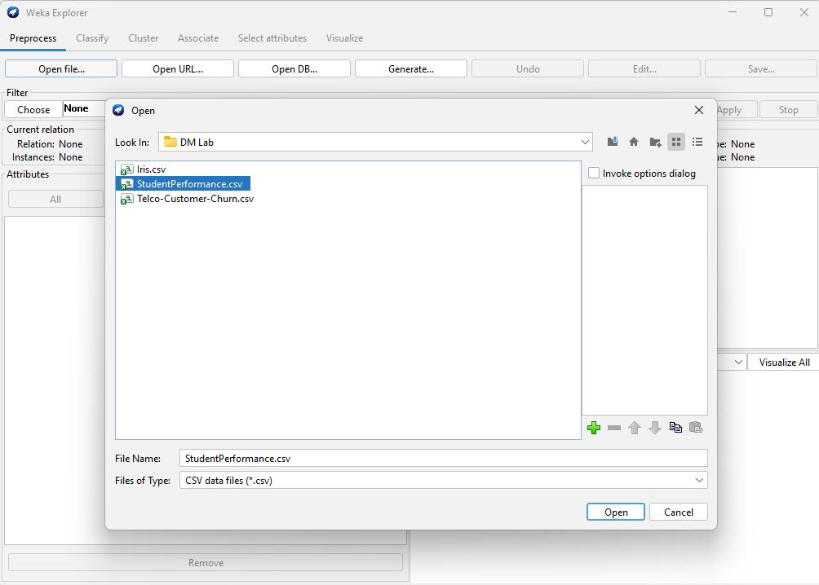
Instance 10000
Attribute 8
In K-Means clustering, all attributes are used to group similar students. The attributes used are:
- Hours Studied
- Previous Scores
- Extracurricular Activities
- Sleep Hours
- Sample Question Papers Practiced
- Performance Index
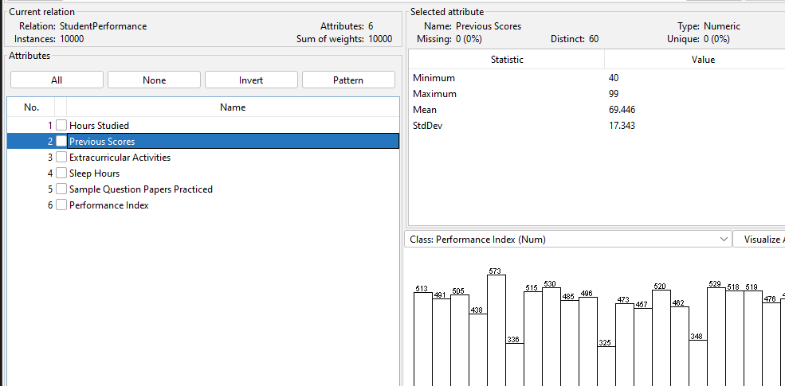
Task 02: Apply K-Mean
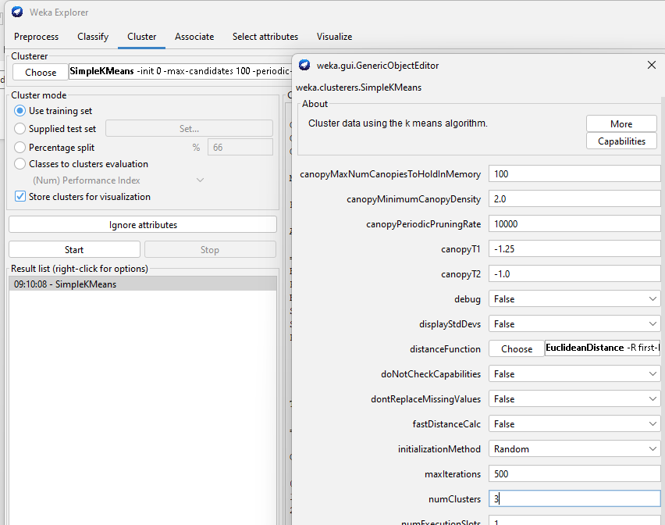
And then click on start
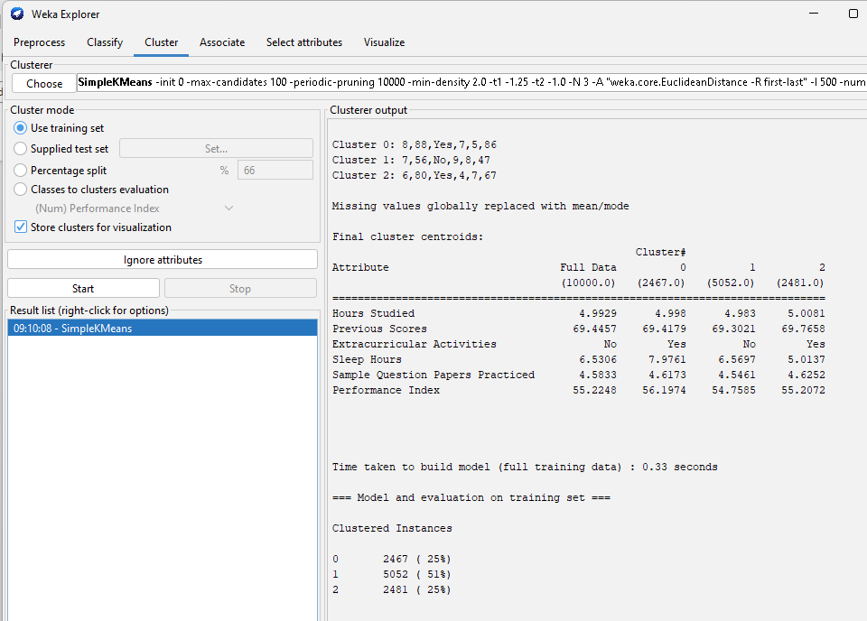
Three Clusters generated:
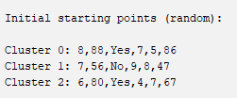
Clustered Instances
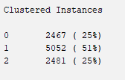

Task 03
centroid values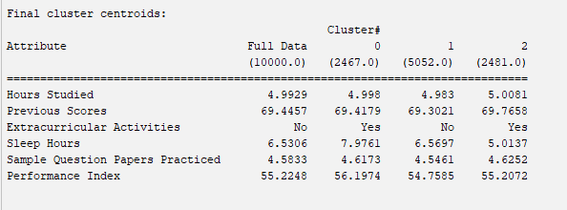

Low-Performing Students
Cluster 1 represents low-performing students.
Reason:
- It has the lowest Performance Index (54.7585) among all clusters.
- Students in this cluster have slightly lower previous scores and fewer practiced papers compared to other clusters.

High-Performing Students
Cluster 0 represents high-performing students.
Reason:
- It has the highest Performance Index (56.1974).
- Students in this cluster also have higher sleep hours and good study habits, which may contribute to better academic performance.
Task 04

NumCluster: 4
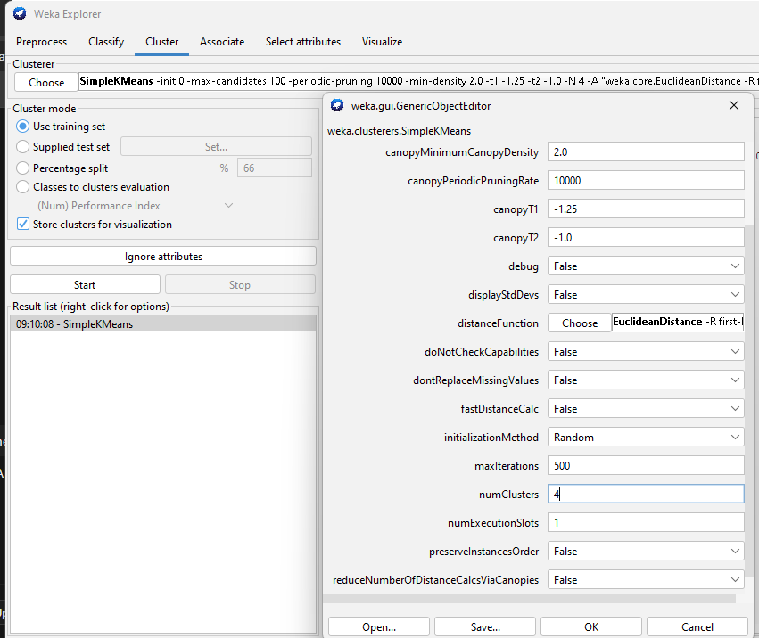
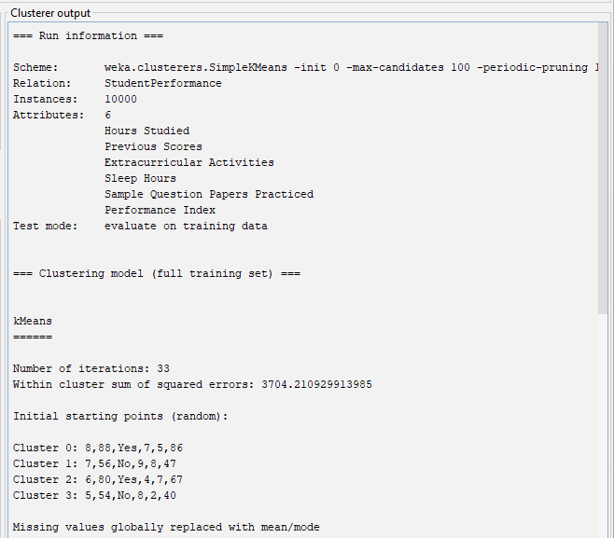
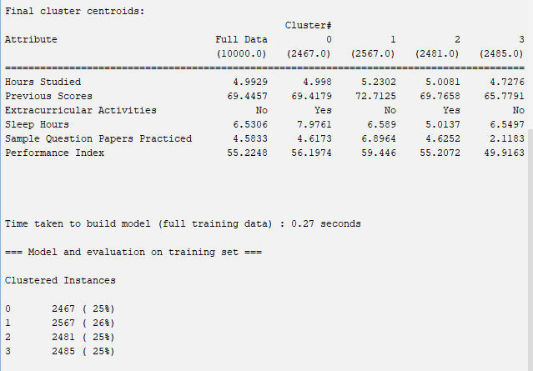
1. What changes do you observe in the clustering results?
When the number of clusters increased from 3 to 4, the following changes occurred:
- Number of clusters increased from 3 to 4 clusters.
- The dataset was divided into four groups instead of three, giving more detailed grouping.
- The within-cluster sum of squared errors decreased:
  - For K = 3: 4096.75
  - For K = 4: 3704.21
This means the clusters became more compact and better separated.
- Students were divided into more specific performance groups:
  - Cluster 1: Highest performance (Performance Index ≈ 59.446)
  - Cluster 0: Good performance (≈ 56.19)
  - Cluster 2: Average performance (≈ 55.21)
  - Cluster 3: Low performance (≈ 49.91)
This shows that K = 4 separates students more clearly according to their academic performance and study behavior.
2. Which value of K produces better clusters?
K = 4 produces better clusters.
Reason:
- The Within Cluster Sum of Squared Errors (SSE) is lower (3704.21) than when K = 3 (4096.75).
- Lower SSE indicates better clustering quality because the data points are closer to their cluster centroids.
- It also creates more detailed groups of student performance.

Task 05
Interpretation
Characteristics of Each Cluster
Cluster 0:
Good-performing students with balanced study hours and sleep and moderate practice.
Cluster 1:
High-performing students with higher previous scores and more sample paper practice.
Cluster 2:
Average-performing students with moderate study but lower sleep hours.
Cluster 3:
Low-performing students with lower previous scores and very little practice.

